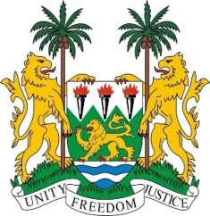

**SIERRA LEONE**

**45th Session of the UPR Statement**

**Central African Republic**

Friday, 25 January, 2024

**Check against delivery**

**Mr President,**

Sierra Leone welcomes **H.E Mr. Arnaud Djoubaye Abazene, Minister of State for Justice, Human Rights and Good Governance** and the distinguished delegation of the Central African Republic and thanks them for their presentation.

My delegation commends the Central African Republic (CAR) for its commendable efforts to prioritise health, particularly through the formulation of the Third National Health Development Plan 2019-2030 and the establishment of a national policy on health care in prisons.

Sierra Leone also welcomes the notable progress made by the Special Court, in particular the commencement of hearings in cases involving alleged perpetrators of serious crimes committed during the armed conflict. The renewal of its mandate further underscores the commitment to address historical injustices and promote accountability.

In the spirit of constructive dialogue Sierra Leone offers the following recommendations.

1. Conduct comprehensive investigations and prosecutions of all cases of sexual violence against women and girls.
2. Revitalize the implementation process of the Luanda Agreement and the Luanda Joint Roadmap, demonstrating a commitment to the 217 recommendations arising from the Republican Dialogue.

My delegation urges the international community to redouble its support for the Central African Republic's (CAR) efforts to fulfill its human rights commitments and obligations through increased technical and financial assistance.

Sierra Leone wishes the CAR a successful fourth cycle review.

Thank you, **Mr President**.